**LAB MST-: Mobile Application Development**

**Student Name: MONIKA SURANA**

**Subject Code: 20CAB-717**

**UID: 20MCA1373 Section/Group: 4B**

**Semester: 3rd Date of Performance: 04-10-2021**

**Experiment No. 3**

1. **Aim/Overview of the practical:**

**Task to be done:**

**Experiment No. 3: Create an Android Application using kotlin having three Activities: Splash Screen, Registration Form, and Profile.**

**Send data of registration form activity ton the profile activity.**

|  |
| --- |
|  |

1. **Algorithm/Flowchart :**
2. **Code for experiment/practical:**

**SplashScreen.xml:**

<?xml version="1.0" encoding="utf-8"?>  
<LinearLayout xmlns:android="http://schemas.android.com/apk/res/android"  
 xmlns:app="http://schemas.android.com/apk/res-auto"  
 xmlns:tools="http://schemas.android.com/tools"  
 android:layout_width="match_parent"  
 android:layout_height="match_parent"  
  
 android:gravity="center"  
  
 android:orientation="vertical"  
 tools:context=".SplashScreen">  
 <TextView  
 android:layout_width="wrap_content"  
 android:layout_height="wrap_content"  
 android:text="Registration"  
 android:textSize="50dp"  
 android:textColor="@color/white"  
 />  
 <TextView  
 android:layout_width="wrap_content"  
 android:layout_height="wrap_content"  
 android:text="Form"  
 android:textSize="50dp"  
 android:textColor="@color/white"  
 android:layout_margin="30dp"  
 />  
  
  
  
  
  
  
  
</LinearLayout>

**MainActivity.xml:**

<?xml version="1.0" encoding="utf-8"?>  
<LinearLayout xmlns:android="http://schemas.android.com/apk/res/android"  
 xmlns:app="http://schemas.android.com/apk/res-auto"  
 xmlns:tools="http://schemas.android.com/tools"  
 android:layout_width="match_parent"  
 android:layout_height="match_parent"  
 android:orientation="vertical"  
 android:gravity="center"  
 tools:context=".MainActivity">  
 <TextView  
 android:layout_width="wrap_content"  
 android:layout_height="wrap_content"  
 android:text="Registration"  
 android:textSize="50dp"  
 android:textColor="@color/white"  
 android:layout_marginBottom="100dp"  
 />  
 <EditText  
 android:layout_width="350dp"  
 android:layout_height="wrap_content"  
 android:background="@color/white"  
 android:textSize="30dp"  
 android:text="USER NAME"  
 android:textAlignment="center"  
 android:id="@+id/name"  
 android:textColor="@color/black"  
 android:layout_margin="20dp"  
 />  
  
 <EditText  
 android:layout_width="350dp"  
 android:layout_height="wrap_content"  
 android:background="@color/white"  
 android:textSize="30dp"  
 android:text="USER ID"  
 android:textAlignment="center"  
 android:id="@+id/uid"  
 android:textColor="@color/black"  
 android:layout_margin="20dp"  
 />  
 <EditText  
 android:layout_width="350dp"  
 android:layout_height="wrap_content"  
 android:background="@color/white"  
 android:textSize="30dp"  
 android:text="Phn. Number"  
 android:textAlignment="center"  
 android:id="@+id/number"  
 android:textColor="@color/black"  
 android:layout_margin="20dp"  
 />  
 <Button  
 android:layout_width="350dp"  
 android:layout_height="wrap_content"  
 android:text="Register"  
 android:layout_margin="20dp"  
 android:textColor="@color/white"  
 android:textSize="30dp"  
 android:id="@+id/register"  
 />  
  
  
</LinearLayout>

**Second Activity:**

<?xml version="1.0" encoding="utf-8"?>  
<androidx.constraintlayout.widget.ConstraintLayout xmlns:android="http://schemas.android.com/apk/res/android"  
 xmlns:app="http://schemas.android.com/apk/res-auto"  
 xmlns:tools="http://schemas.android.com/tools"  
 android:layout_width="match_parent"  
 android:layout_height="match_parent"  
 tools:context=".SecondActivity">  
  
 <TextView  
 android:id="@+id/tv_username"  
 android:layout_width="match_parent"  
 android:layout_height="wrap_content"  
 app:layout_constraintTop_toTopOf="parent"  
 app:layout_constraintBottom_toBottomOf="parent"  
 android:textSize="18sp"  
 android:textStyle="bold"  
 android:text="Username"  
 android:layout_margin="15sp"  
 android:gravity="center"  
 android:textColor="#FF00"  
 />  
  
  
 <TextView  
 android:id="@+id/tv_uid"  
 android:layout_width="match_parent"  
 android:layout_height="wrap_content"  
 app:layout_constraintTop_toBottomOf="@id/tv_username"  
 android:textSize="18sp"  
 android:textStyle="bold"  
 android:text="Password"  
 android:layout_margin="15sp"  
 android:gravity="center"  
 android:textColor="#FF00"  
 />  
  
  
  
</androidx.constraintlayout.widget.ConstraintLayout>

**SplashScreen.kt:**

package com.example.demoapp  
  
import android.content.Intent  
import androidx.appcompat.app.AppCompatActivity  
import android.os.Bundle  
import android.os.Handler  
import android.view.WindowManager  
  
class SplashScreen : AppCompatActivity() {  
 override fun onCreate(savedInstanceState: Bundle?) {  
 super.onCreate(savedInstanceState)  
 setContentView(R.layout.*activity_splash_screen*)  
 *window*.setFlags(  
 WindowManager.LayoutParams.*FLAG_FULLSCREEN*,  
 WindowManager.LayoutParams.*FLAG_FULLSCREEN* )  
 Handler().postDelayed(**{** val intent = Intent(this, MainActivity::class.*java*)  
 startActivity(intent)  
 finish()  
 **}**, 3000)  
 }  
}

**MainActivity.kt:**

package com.example.demoapp  
import android.content.Intent  
import androidx.appcompat.app.AppCompatActivity  
import android.os.Bundle  
import android.widget.Button  
import android.widget.EditText  
class MainActivity : AppCompatActivity() {  
 private lateinit var btnSendData : Button  
 private lateinit var editUserName : EditText  
 private lateinit var editUid : EditText  
 private lateinit var editPhn : EditText  
 override fun onCreate(savedInstanceState: Bundle?) {  
 super.onCreate(savedInstanceState)  
 setContentView(R.layout.*activity_main*)  
  
 btnSendData = findViewById(R.id.*register*)  
 editUserName = findViewById(R.id.*name*)  
 editUid = findViewById(R.id.*uid*)  
 editPhn = findViewById(R.id.*number*)  
  
 btnSendData.setOnClickListener **{** startActivity(Intent(this,SecondActivity::class.*java*)  
 .putExtra("username",editUserName.*text*.toString())  
 .putExtra("uid",editUid.*text*.toString())  
 .putExtra("number",editPhn.*text*.toString()))  
 **}** }  
}

**SecondActivity.kt:**

package com.example.demoapp  
  
import androidx.appcompat.app.AppCompatActivity  
import android.os.Bundle  
import android.widget.TextView  
import org.w3c.dom.Text  
class SecondActivity : AppCompatActivity() {  
 private lateinit var textUserName : TextView  
 private lateinit var textUid : TextView  
  
 override fun onCreate(savedInstanceState: Bundle?) {  
 super.onCreate(savedInstanceState)  
 setContentView(R.layout.*activity_second*)  
 textUserName = findViewById(R.id.*tv_username*)  
 textUid = findViewById(R.id.*tv_uid*)  
  
 val userName = *intent*.getStringExtra("username")  
 val uid = *intent*.getStringExtra("uid")  
  
 textUserName.*text* = "Username : "+userName  
 textUid.*text* = "Password : "+uid  
 }  
}

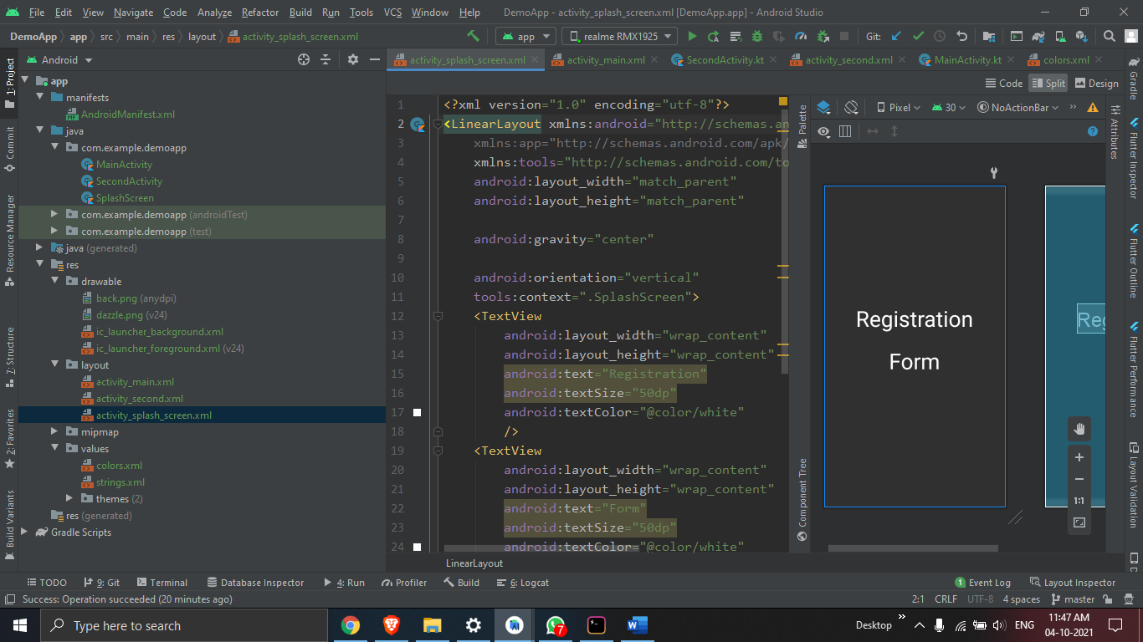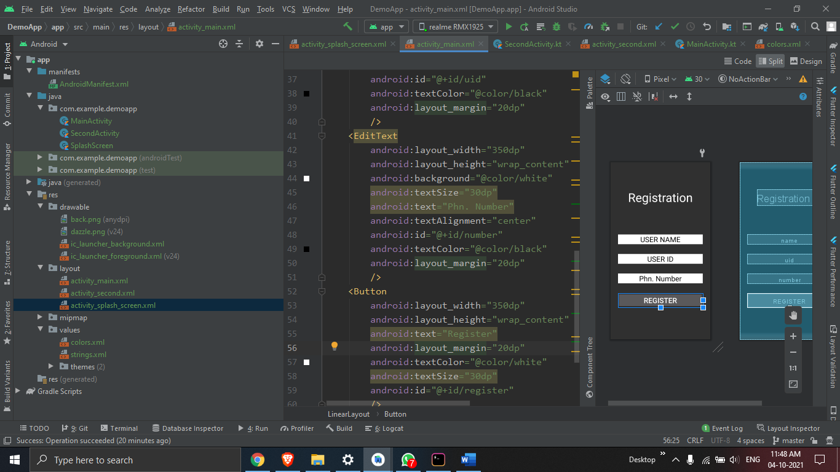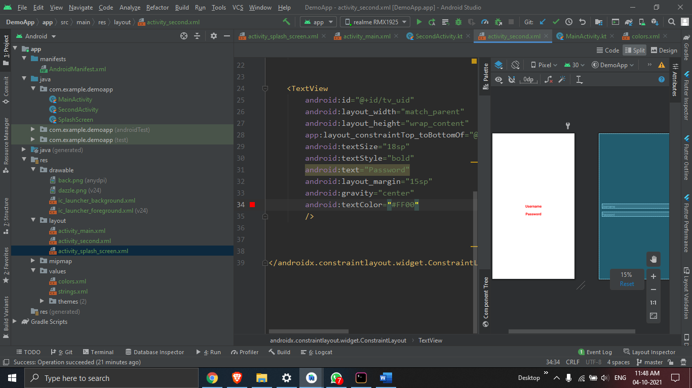

1. **Result/Output/Writing Summary:**

